Tryout Planning Automation
Table of Contents
Overview of Tryout Planning 1
Script for Automation Tryout Planning Preparation 1
Prerequisites 2
Inputs in the init.xlsx file 2
How to run the script 2

Overview of Tryout Planning:

Tryout planning is the first step in Tryout activity. Tryout Planning contains SW details, Stick/ Image path, tryout result collection path, Map details, target date, Sister device details, Bosch Part number, CD/PD details, tryout sub JIRA task ID etc...

Script for Automation Tryout Planning Preparation:
Prerequisites:
- Python 3.9 or Anaconda3 should be installed.
- Dependencies like, Numpy, Pandas, Jira need to be installed.
- Installation procedure for Dependencies:
- Open the CMD prompt with Admin Rights
- Now, change the directory to Anaconda3 (C:\Program Files\Anaconda3).
- Type Conda install “Dependencies name” and then hit ENTER. Eg
- Download the below files in your machine and place it in the same folder.

Inputs in the init.xlsx file:
Before running the script, please provide the inputs in the init.xlsx file.

- Init.xlsx file contains the below header details,
  - Part_Numbers: Fill the Successor Part numbers under this Column.
  - SW_Version: Fill the Software Version eg: 3466_230423
  - Jira_Main_Task: Fill Jira ID of the main Task
  - Jira_TO_Task: Fill Jira ID of the Sub JIRA tryout task
  - PD_Version: Fill the PD Version from the Main task
  - CD_Version: Fill the CD Version from the Main task.
  - ProductType: Select the Product based on the Task, Options: Renault, Nissan, PIVI and Mitsubishi.
  - Base_SW: Fill base SW (Reflash only)
  - Release_Type: Select the options based on the Task, two options: Image and SplUpd.
  - Docushare_CollectionID: Fill the tryout result collection path
  - Tryout_Location : COB or HI
  - FCID_Version: Fill the FCID Table DS Version (eg: V651). (It is useful only when you run the Sister device script.)
  - HW_List: Fill the HW list excel file name. If you have different filename please add it in the Valid List Sheet under HW_List.
  - Private_Key: Fill if the release has private key or not.
  - Jira_Access_Token: Fill Access token which has a validity for 180 from the date of creation.
  - Task_Name: Fill the Task Name. (Sample Build info in the planning sheet).
How to run the Script:
- Open the CMD Prompt from the location where the scripts and input files are located.
- Type “conda activate base”
- Execute “C:\Program Files\Anaconda3\python.exe” TryoutMailGenerator.py
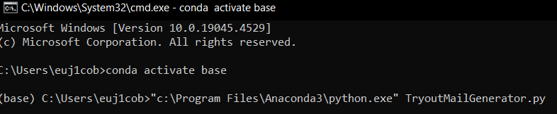
Tryout mail will be drafted, and the Jira Task is updated automatically.
Note:
Please check the cmd prompt and look for error and warning.

